EXPERIMENT-4-Chennai Property Hub

Aim:
To build a cloud-based property management system for buying and renting properties.
Procedure:
- Created a Property form with details like name, location, and price.
- Image upload field was added. A User/Request form was created to handle bookings using lookup fields.
- Sample data and images were added and verified in reports.
Output:
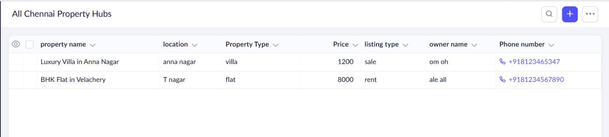
Result:
Property system allows users to view and manage property listings online.

